2/18/14
Parsons Constructors Inc.
Attn: Jessica Jones
100 W. Walnut St.
Pasadena, CA 91124
Fax: 626-440-2516, jessica.jones@parsons.com

San Diego County Building and Construction Trades Council
Attn: Tom Lemmon
3737 Camino Del Rio South, Ste 202
San Diego, CA 92108
Fax: 619-521-2917, tomlemmon@sdbctc.org

Southwest Regional Council of Carpenters
Attn: Michael Magallanes
8595 Miralani Drive, Ste A
San Diego, CA 92126
Fax 858-621-2673, michael@local1506.org

Re: San Diego Unified School District Project Stabilization Agreement Construction and Major Rehabilitation Funded By Proposition S (“PSA”)

To Whom It May Concern:

This is to confirm RBE agrees to be a party to and bound by the San Diego Unified School District Project Stabilization Agreement - School Construction Major Rehabilitation Funded by Proposition S (“PSA”) effective July 28, 2009, consisting of the Resolution dated July 28, 2009, the Agreement between the San Diego Unified School District and the San Diego Building and Construction Trades, the Agreement between the San Diego Unified School District and the Southwest Regional Council of Carpenters, and Addendum No. 1, and as the PSA may, from time to time, be amended by the negotiating parties or interpreted pursuant to its terms. Such obligation to be a party and bound by this Agreement shall extend to all work covered by the Agreement undertaken by this Company on the Project pursuant to SDUSD CONTRACT # CZ-14-0541-08, Soltek Project #937- FURNISH AND INSTALL HVAC SYSTEMS AND ALL ASSOCIATED WORK AT DISTRICT SCHOOL SITES – REGIONS 1-5 (IDIQ), and this Company shall require all of its subcontractors of whatever tier to be similarly bound for all work within the scope of the Agreement by signing and furnishing to you an identical Letter of Assent prior to their commencement of work.
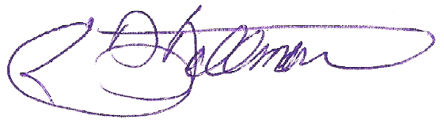
Sincerely,

RBE
By: E. David Ballman
President

